CREATE JAVA APPLICATION

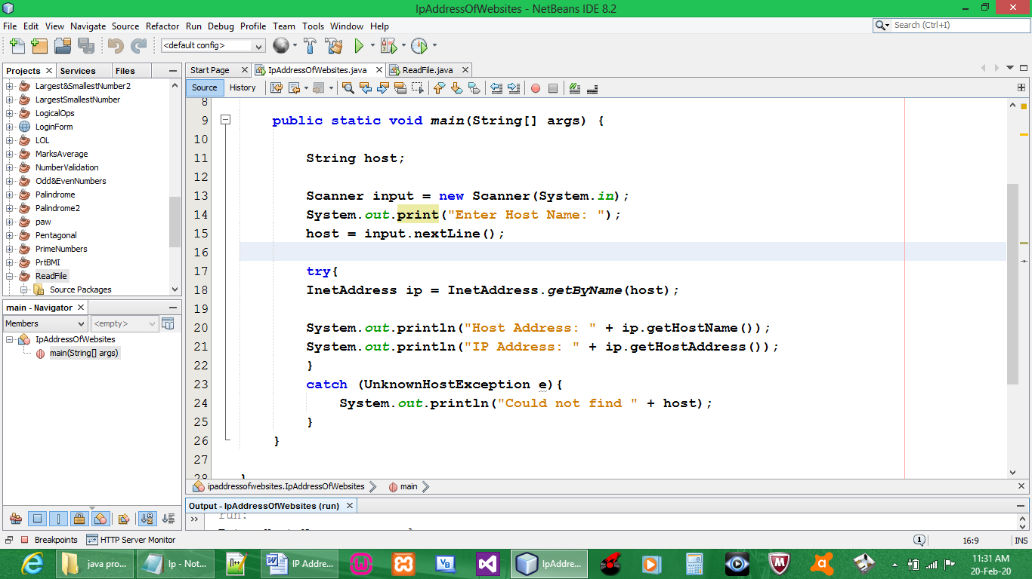

CODE:

package ipaddressofwebsites;

import java.io.*;
import java.net.*;
import java.util.*;

public class IpAddressOfWebsites {

public static void main(String[] args) {

String host;

Scanner input = new Scanner(System.in);
System.out.print("Enter Host Name: ");
host = input.nextLine();

try{
InetAddress ip = InetAddress.getByName(host);

System.out.println("Host Address: " + ip.getHostName());
System.out.println("IP Address: " + ip.getHostAddress());
}
catch (UnknownHostException e){
System.out.println("Could not find " + host);
}
}

}

OUTPUT:

